**Subscribers galore :Exploring world’s Top youtube channels]**

**1.Introduction :**

**1.1.Overview:**

Problem Understanding, also known as Problem Definition or Problem Identification, is the initial and critical phase of any data analysis or problem-solving process. It involves gaining a clear and comprehensive understanding of the problem at hand, its context, scope, and objectives.

**1.2 Prupose :**

Channel Information: Each YouTube channel should have a dedicated page or profile that displays essential information, including the channel name, description, subscriber count, video views, upload frequency, and engagement metrics.

Subscription Management: Users should have the ability to subscribe to their favourite YouTube channels within the platform, allowing them to receive notifications about new uploads and updates from those channels.

**2.Problem statement & Design thinking**

Analytics and Insights: The platform should provide analytics and insights to track user engagement, popular channels, and trending content. This data can be used to improve content curation, personalize recommendations, and enhance the overall user experience.

These business requirements aim to create a user-friendly platform that facilitates the exploration and discovery of YouTube channels, while also providing features for personalization, social interaction, and monetization. By meeting these requirements, the platform can enhance user engagement and satisfaction, while also creating opportunities for revenue generation and growth.

3.Result :

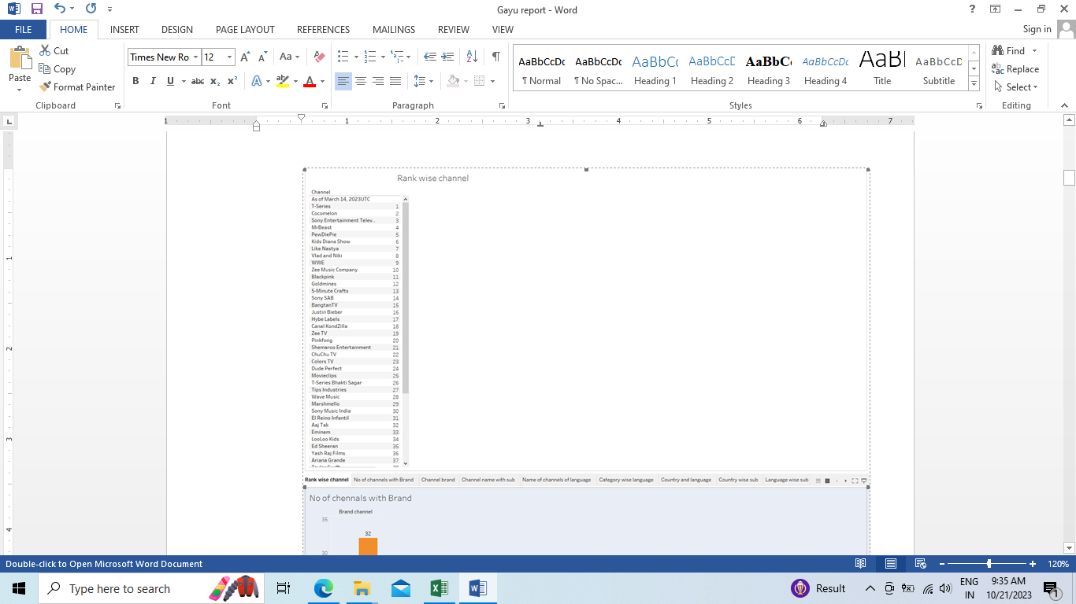

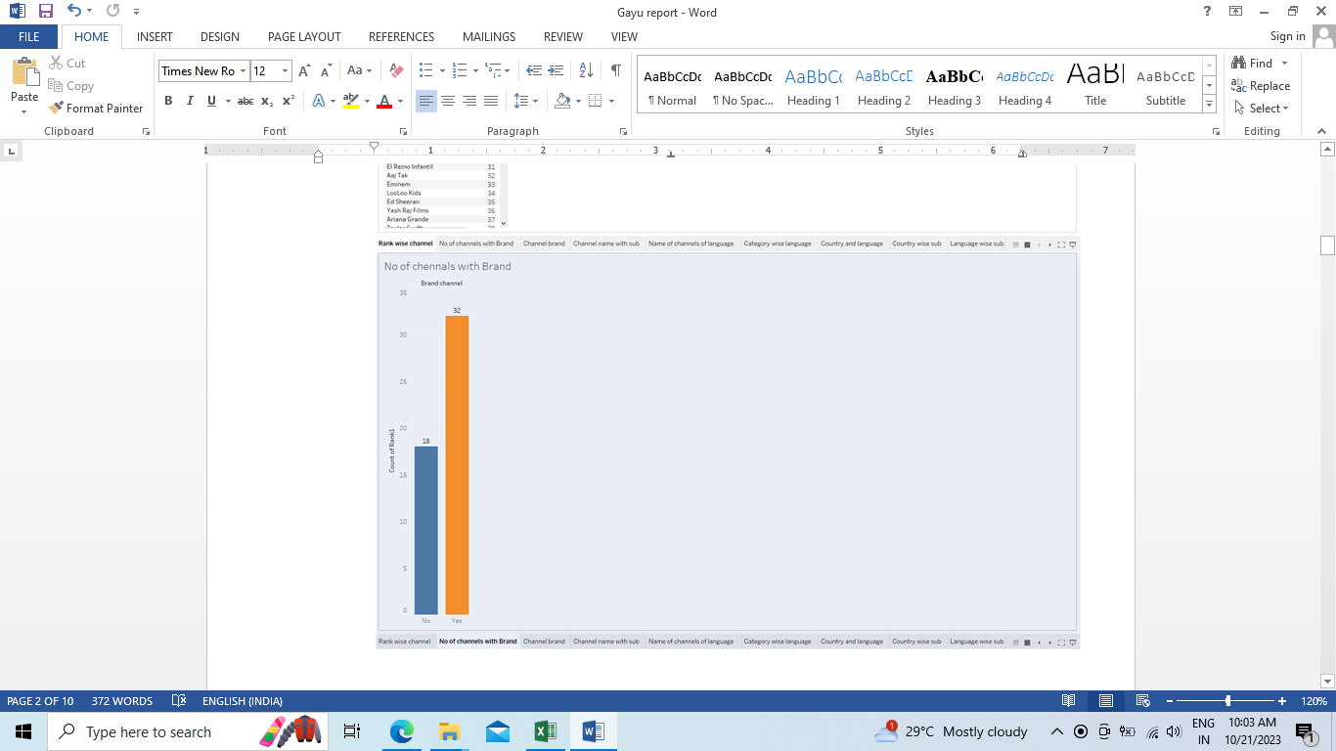

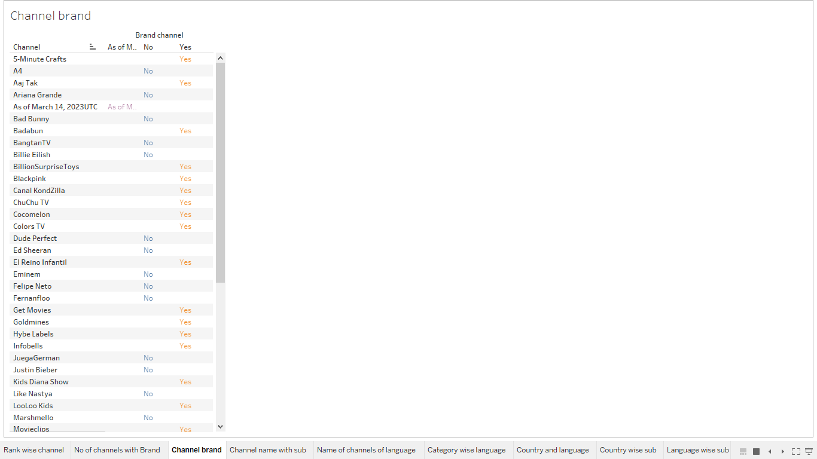

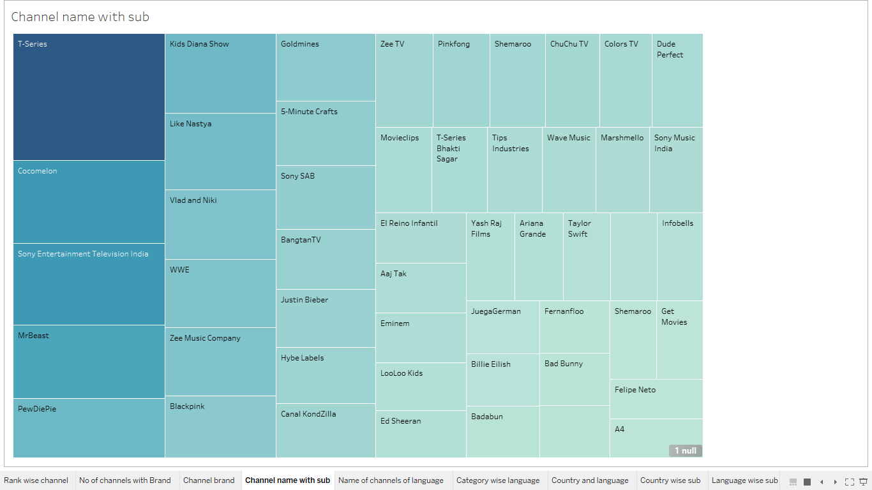

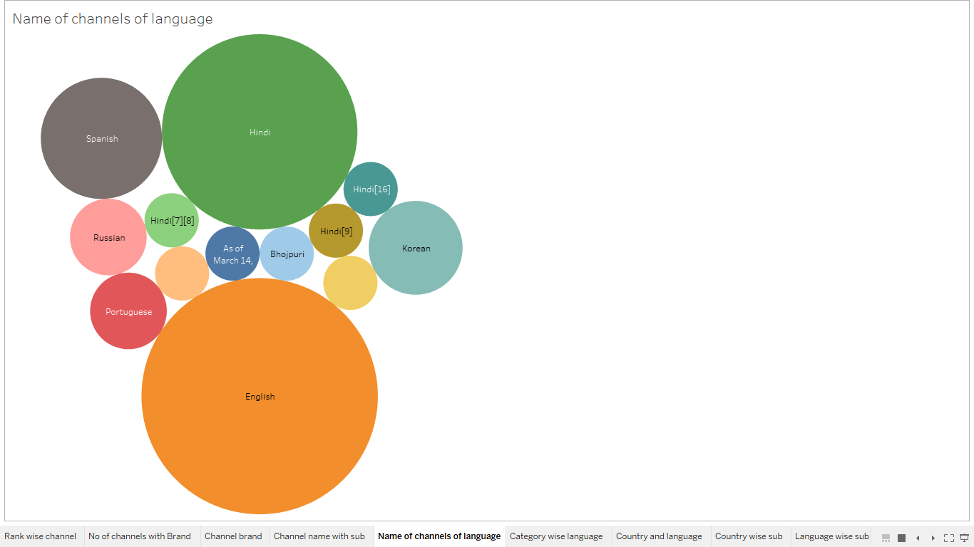

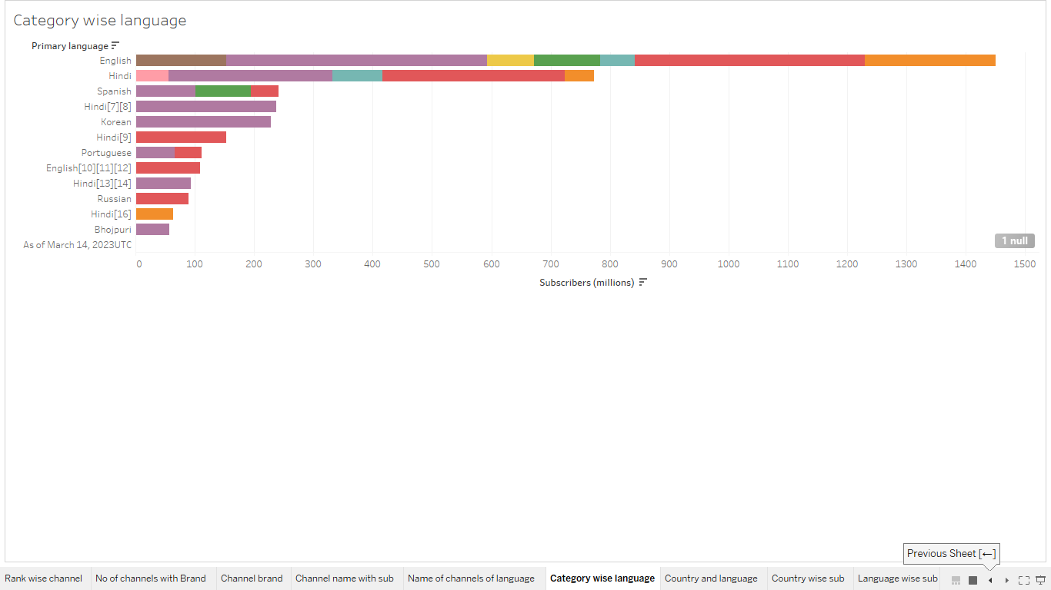

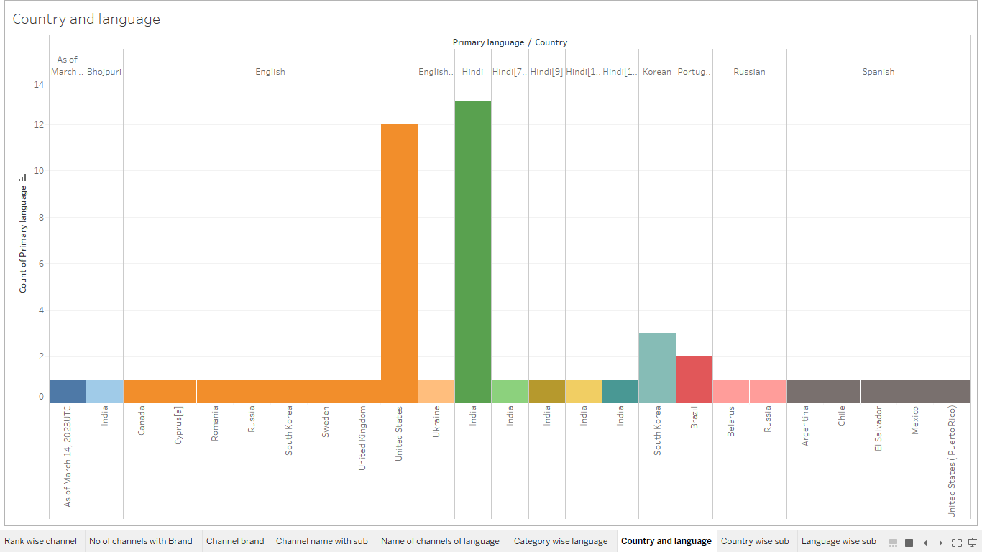

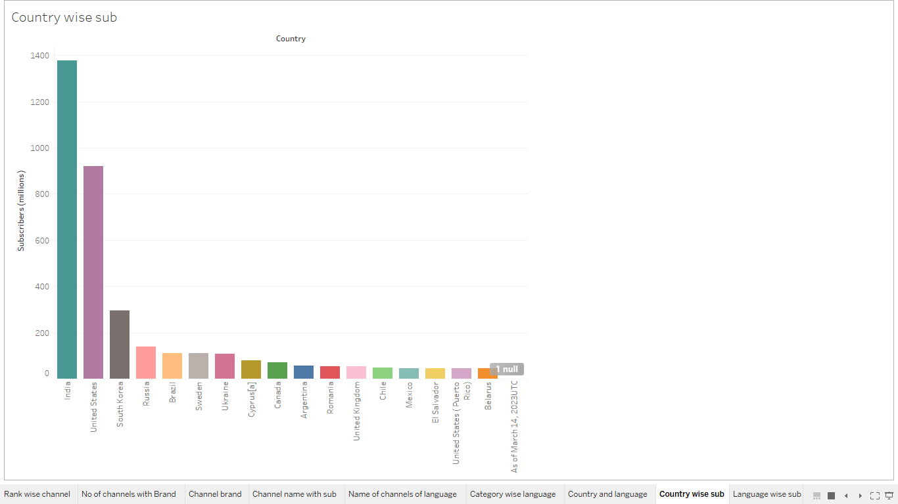

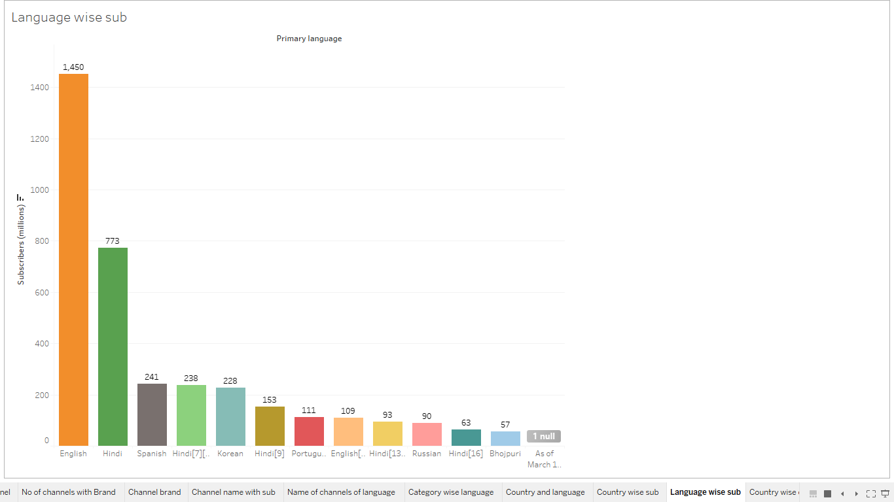

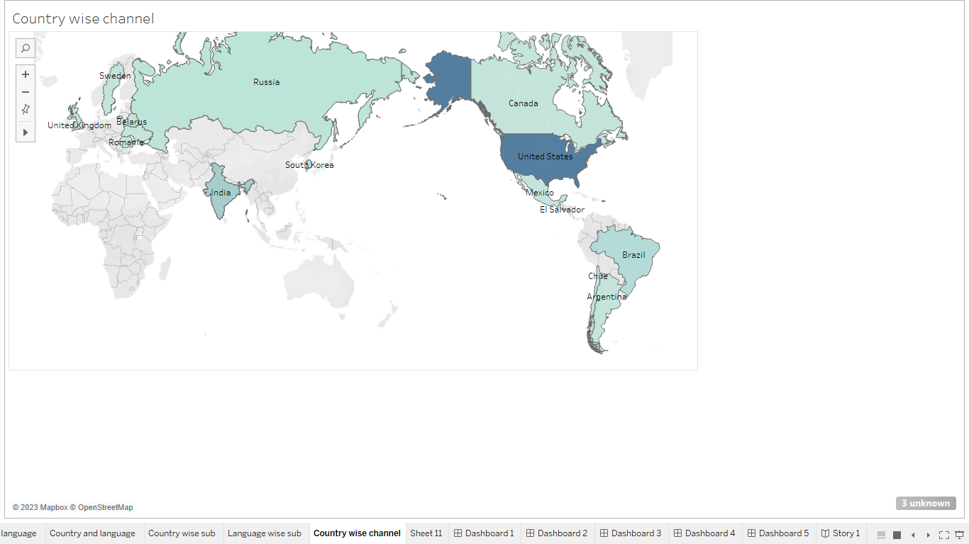

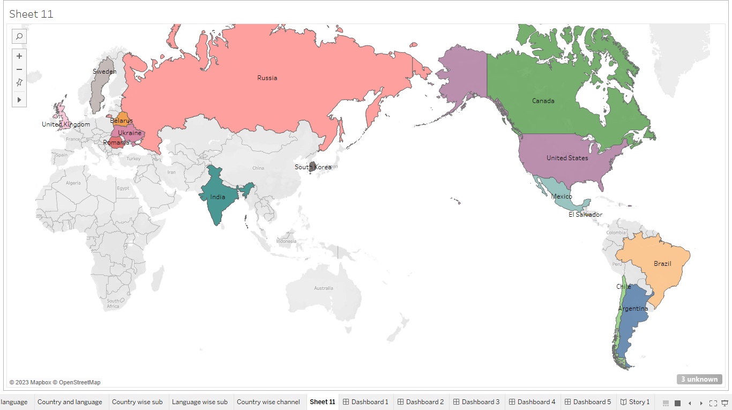

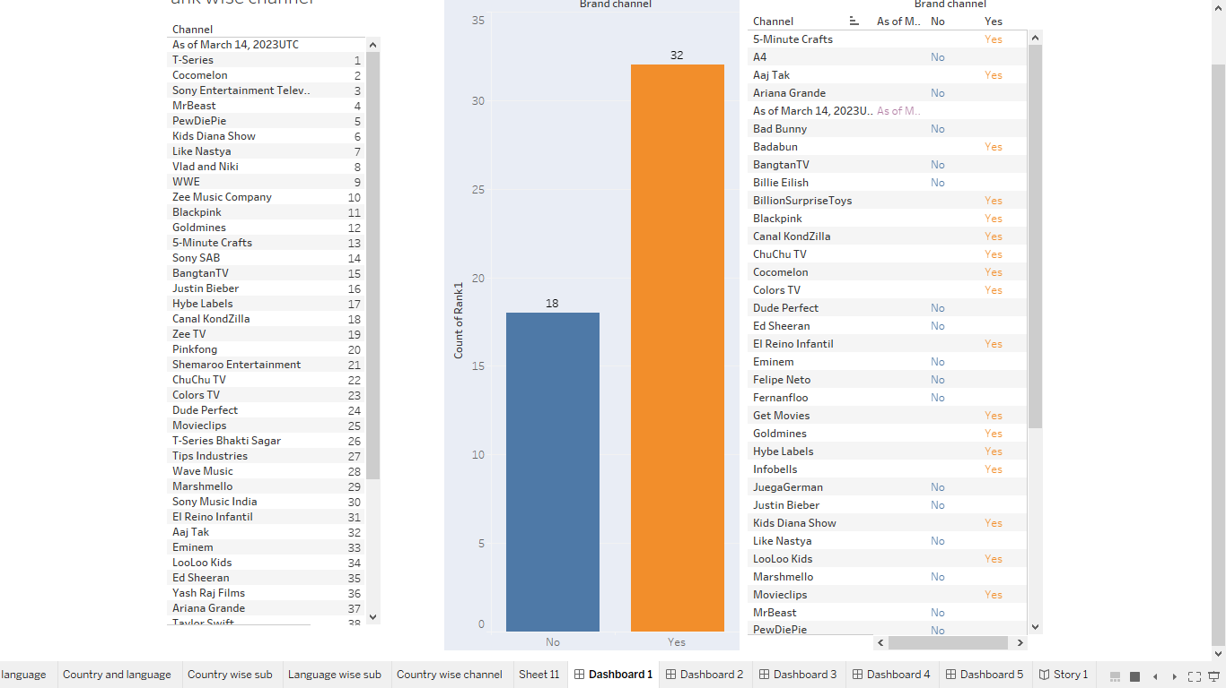

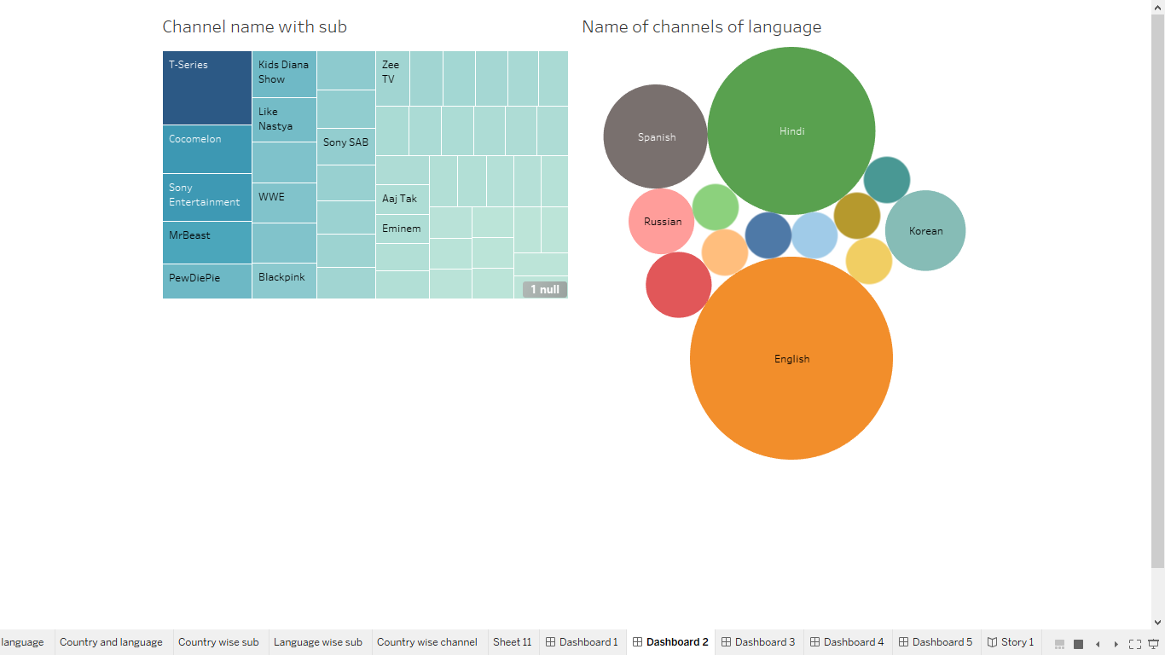

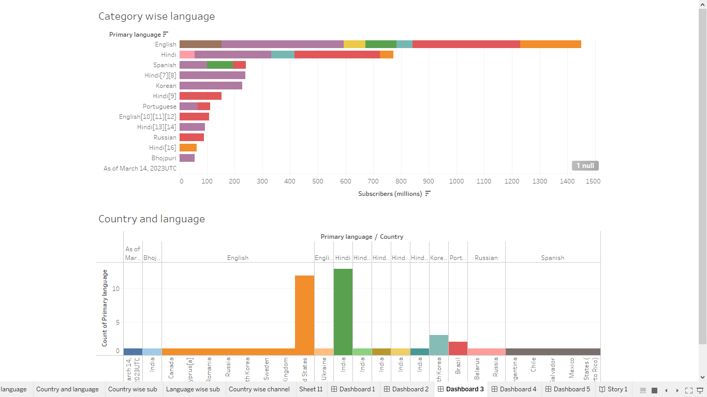

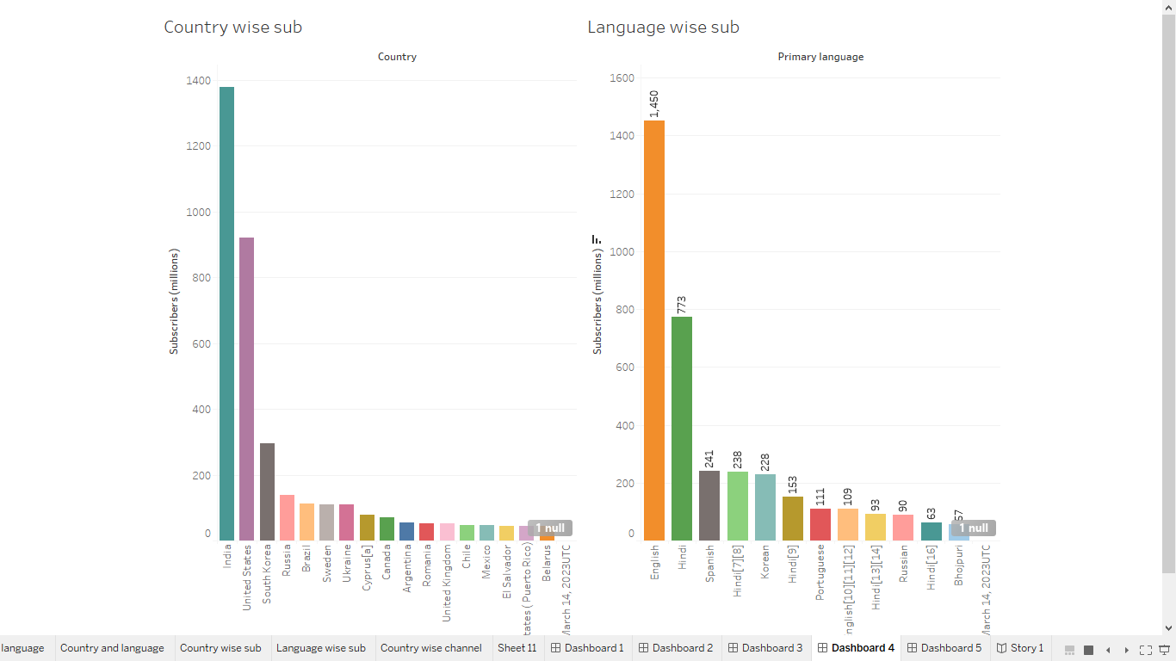

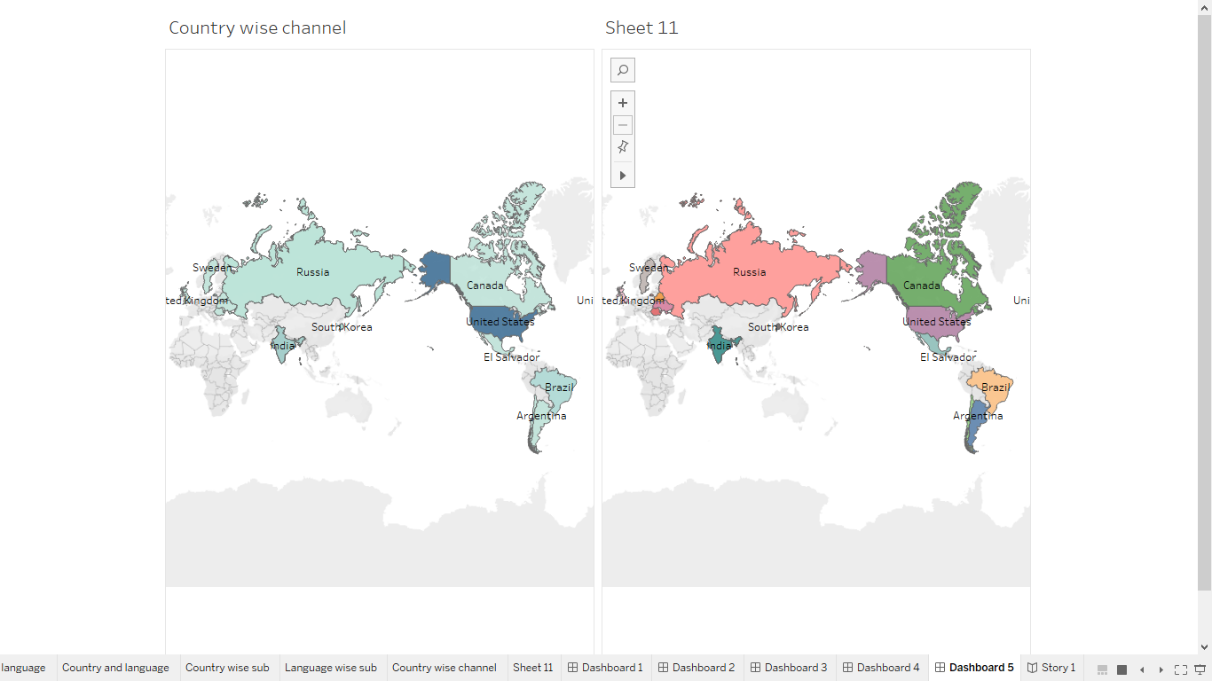

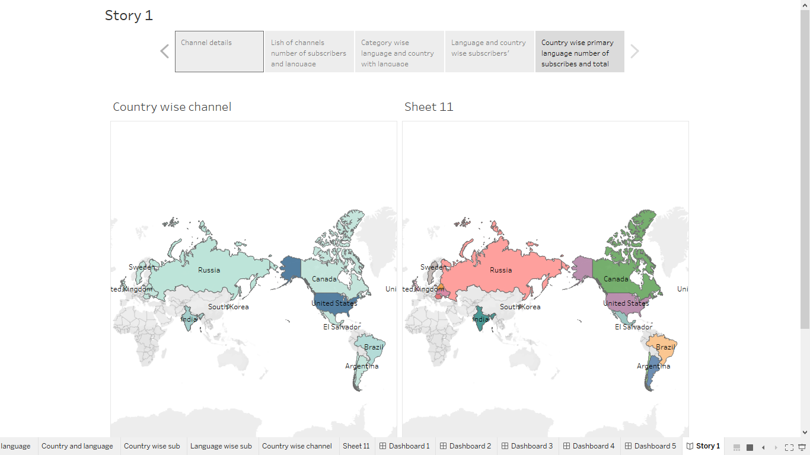

**4. Advantage & Disadvantages:**

**Advantages:**

1. Massive Reach: Top channels have millions of subscribers, allowing them to reach a vast audience globally.

2. Monetization Opportunities: High subscriber counts lead to more ad revenue, sponsorships, and merchandise sales.

3. Brand Collaborations: Top channels can collaborate with well-known brands, leading to lucrative partnerships.

4. Influence: They have the power to influence trends, opinions, and consumer behavior.

5. Diverse Revenue Streams: Apart from ads, they earn from memberships, Super Chats, and YouTube Premium revenue.

**Disadvantages:**

1. Pressure to Perform: There's constant pressure to maintain high-quality content and engage the audience to sustain the channel's popularity.

2. High Expectations: Viewers have high expectations, making it challenging to meet their demands consistently.

3. Burnout: Creators may face burnout due to the demand for frequent uploads and creative exhaustion.

4. Criticism and Scrutiny: Top channels often face intense scrutiny and criticism from viewers and competitors.

Dependency on YouTube: Changes in YouTube algorithms or policies can affect the channel's visibility and revenue